Anti-theft Security Lock

Section: P Submitted By:

S M Tusher Mustakim

ID: 19-40861-2

Anti-theft Security Lock

S M Tusher Mustakim

*Computer Science and Engineering Department, American International University, Bangladesh*

[smtusher007@gmail.com](mailto:smtusher007@gmail.com)

***Abstract* — In this paper, I will deliberate how to control house safety and security system using technology and by using android application through android mobile phone. I will also show that we can control the appliances even in the absence of an android phone by sending a normal notification. The advantage of using technology is that we can control the home security from anywhere in the world. This system allows the owner to control the security of the house and also the app shows the emergency sections if there is any emergency situation in the house.**

***Index Terms* — Electronic devices, Mobile application, Sensor, Police Station**

I. Introduction

The wireless communication is increasing day by day. This has motivated us to use mobile phones to remotely control household appliances. Nowadays mobile phone take its own place in everyone’s hand. In the meantime everyone live in a society. All the people of a society are not gentle as others. Some people try to theft in other’s houses. It’s a common problem all over the country. In the benefit of technology people can easily control their house or workshop security. As smartphone is used by everyone, people can use a mobile app to control their house’s security. A device that will be installed in the door lock and windows. If anyone try to break the door a notification will be sent to the owner’s mobile phone and he/she can see what is happening in his/her house via CCTV camera if there have any. There will be also an option to report to the nearest police station. An emergency call be done by the house owner’s mobile phone to police station. This whole process will be done by a mobile app which will be connected to the device. The app can be made by C++, Java or Python language. But Java is the most preferable language to develop the app.

II. Methodology

494 theft movement was happened in all over the country during the year 2019 and this journal was published by Bangladesh Police. Also the theft movement is increasing every year. As this is a public research so several people was asked several questions. Questions was asked by google form and 10 people respond in the survey. They were asked where they live. A question was asked if the people have experienced theft movement in their area. As this is an era of technology all of the people have smartphones. They were also asked if they have any smartphone or not.

III. Results

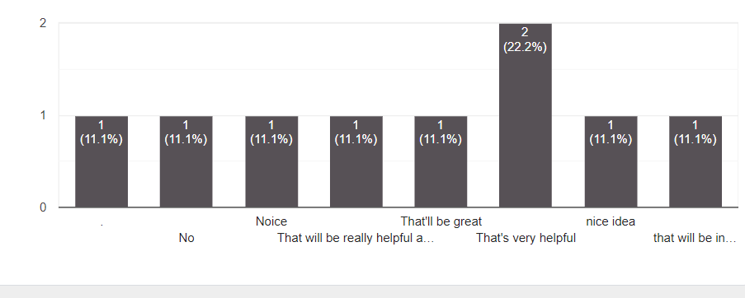As the country has so much theft problem during many years, people want get relief of it. Those people who was asked questions 80% of them lives in town and 10% of them lives in villages and other 10% people lives in down town. All of them have smartphones and 80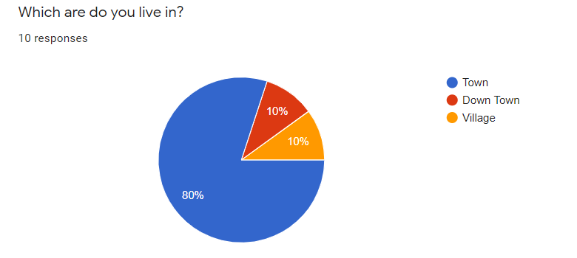% of them don’t have any security guards in their house. 10% of the people have 3 to 6 CCTV cameras in their house and 10% of them have 1 CCTV cameras in their house. But most of the people don’t have any CCTV cameras in their house. Nowadays is essential to have at least one CCTV camera in anyone’s house. 50% of the people have experienced theft movement in their area. So people need more security to protect their house from thief. The people were also asked by which material their house doors are made of. 70% of the people’s house have wooden door, 10% people have steel door and another 20% people have stainless steel door. A device will be installed their door, so that the material of the door is important. The device will detect the door’s motion sensor and also can measure if there any person entering form the door. The people was also asked if they have any balcony in their house and the balconies have barricades or not. 55.6% people have balconies in their house and 88.9% of them have barricades in their balconies. A device that can detect any object will be installed in the balconies and windows. If anyone try to break the window or balcony’s barricades the device will notify the owner of the house by SMS and when the user of the app will turn on his/her internet connection he/she can see what is happening in his/her house by the CCTV camera if there is any. The emergency call will be done if the user allow.

IV. Conclusion

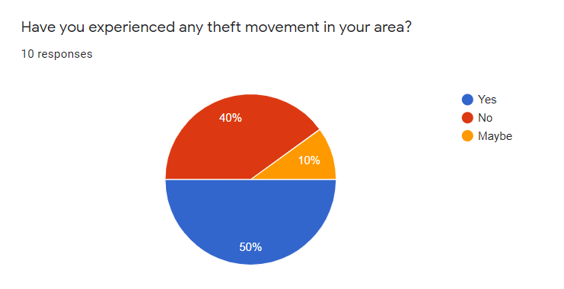In every area of our country there are lots of cases of theft and it’s a common problem nowadays. So a digital security system called Anti-theft Security lock will make our security more strong. A device with sensor system will be installed in a house. If there is any motion detect by the device, a notification will be send to the user’s mobile phone. This technique is quiet difference from other security system in the market because this app can locate the device location and collect phone number of the nearest police station. But there is some problem regarding to do this process. The device must connect to the internet and when the user will open the mobile app the mobile should be in internet access. And our country have a great issue with internet connectivity. Some of the places don’t have a strong internet connectivity. Another problem is the devices are not much available in our country. So that the price of the devices are may be expensive. Future researchers can make a device will be cheap so that everyone can afford it.

References

[1] Electronic devices availability: <https://www.nationmaster.com/nmx/ranking/electrical-equipment-and-electronics-output>

[2] Fitchard, K. (2012, October 22). Retrieved from <https://gigaom.com/2012/10/22/the-average-us-subscriber-owns-1-57-mobile-devices/>

[3] NetMarketShare. (2015, July). Retrieved July 2015, from <https://www.netmarketshare.com/operating-system-marketshare.aspx?qprid=8&qpcustomd=1>

[4] Theft percentage in Bangladesh (Bangladesh Police): <https://www.police.gov.bd/en/crime_statistic/year/2019>